Clearance Items

Gloves
541-1918 XSml Latex Powder Free Glove 10x100/case $73.40/case
541-0076 XLrg Latex Powder Free Glove 10x100/case $71.80/case
541-0190 XXL Vinyl Powder Free Glove 10x100/case $42.00/case

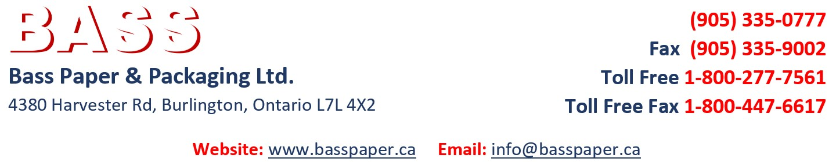
Hand Soap / Sanitizer Stand
586-0004 Universal Soap/Sanitizer Stand $142.50/ea.

Bags
081-0341 10x10 2mil Clear Poly Bag 2000/case $69.90/case
045-0141 14Lb Kraft Grocery Bag 500/bdl $40.50/bdl

Tape
873-0112 #134 36mm x 55m Kraft Flatback Tape 24rl/case $36.65/case
873-0110 #134 24mm x 55m Kraft Flatback Tape 36rl/case $73.90/case

Mailers
584-0068 6x9 Poly Courier Envelopes 1000/case $65.35/case
585-0005 #000 4x8 Kraft Bubble Mailer 500/case $60.50/case
585-0032 #3 8.5 x 14.5 Kraft Bubble Mailer 100/case $23.90/case
585-0242 #2 8.5 x 12 Poly Bubble Mailer 100/case $26.00/case
585-0246 #3 8.5 x 14.5 Poly Bubble Mailer 100/case $30.50/case

Steel Strapping Items
947-1055 ½” Premium Sealer/Crimper $55.00/ea.
825-1225 ¾” Push on Closed Seals 2000/box $71.35/box

