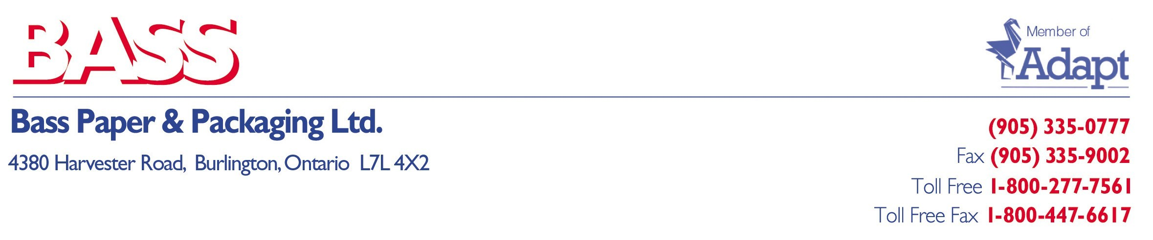
February 01, 2022

To Bass Paper & Packaging Customers:

Unprecedented volatility in the global market has continued to increase as we begin 2022. Unfortunately, this volatility is not expected to settle for several months to come.

As Bass Paper enters our 38th year in business, we have never experienced anything like this, including the “Great Recession”. Covid-19 has wreaked havoc on our entire planet. Our problems stem not only from this pandemic but from all the additional fall-out it has created. We are currently seeing a mass number of employee shortages, material shortages, container shortages, container delays, raw material increases, wage increases, border issues, trucking issues, oil price increases…It does not seem to end. All of this has caused a serious global supply and demand issue, directly resulting in constant product price increases.

You have our word that everyone at Bass Paper & Packaging Ltd continues to do their best to minimize these increases wherever and whenever possible. Unfortunately, the severity of these combined issues often handcuffs our attempted solutions. Please know we are constantly trying our best on your behalf.

We thank you for your patience in these trying times and together we will get through this one day at a time. If there is anything in addition that we can do for you, please let us know.

As always, we very much appreciate your business and continued support.

Sincerely,

Chris Galante
President
Bass Paper & Packaging Ltd

