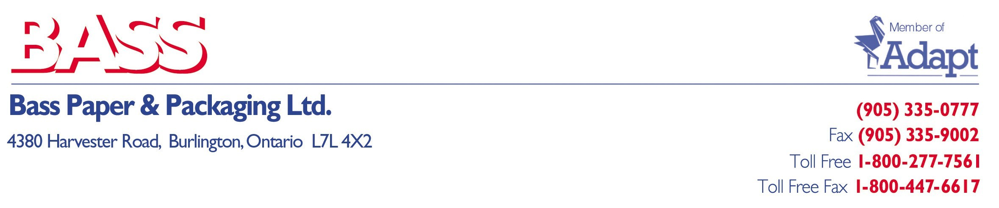

March 12,2025

Dear Valued Customers,

In response to the Canadian Tariffs being implemented, several of our products will be affected in some way, whether the product itself is imported from the U.S. or whether there are components in some form used in the manufacturing process here in Canada. As we are notified of the Tariff on each product, we will inform you at time of ordering

The scale of these Tariffs is something Bass Paper & Packaging Ltd cannot absorb and unfortunately must pass along.

Please know, we will continue to work diligently wherever possible in finding substitutes for products that have been tariffed to help eliminate some of these increased costs.

We at Bass Paper & Packaging Ltd are a 100% CANADIAN OWNED AND OPERATED DISTRIBUTOR and encourage you to investigate the ownership of other distributors in our marketplace which are 100% owned in the United States and donate very, very heavily to the current U.S. Government. Yes, there are some in our backyard.

Please do your due diligence and show your Canadian Patriotism and support those of us that are 100% Canadian Owned and Operated.

Sincerely,

Chris Galante
President

