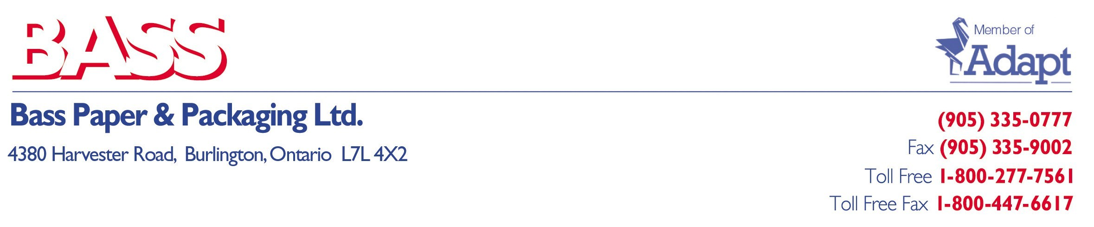March 15, 2022

To Our Valued Customers:

Once again, I find myself in the uncomfortable position of having to pass along some unfortunate updates.

- Effective on all orders placed from March 21, 2022, Bass Paper & Packaging Ltd will increase our minimum order to $500.00. Although we’re aware this will not affect most of our customers, as your orders already exceed $500.00, this notice will affect the balance of customers who were accustomed to our $250.00 dollar minimum, which we have had in place since 1984.

We gently remind you that we sell over 10,000 products and are attaching a Product Summary so you can see what other products you may require and tack them onto your order to help achieve the minimum order. By establishing a “one-stop-shop” you will be able to help minimize your own expenses by having fewer deliveries, purchase orders, invoice matching, payments etc.…

- Effective on all orders placed from March 21, 2022, Bass Paper & Packaging Ltd will be implementing a $25.00 Fuel Surcharge on all orders delivered FOB your dock.

We have been absorbing most of the sky rocketing transportation costs but have found that we can no longer continue to do so. Please know, we will continue to absorb a great deal of these costs, but we do have to pass along this increase.

Again, due to unprecedented transportation costs, we have been left with no other choice if we are to survive these atrocious times.

We thank you for your understanding and patience and please know that we will continue to minimize all increases to the best of our abilities.

As always, we very much appreciate your business and continued support.

Sincerely,

Chris Galante
President
Bass Paper & Packaging Ltd

